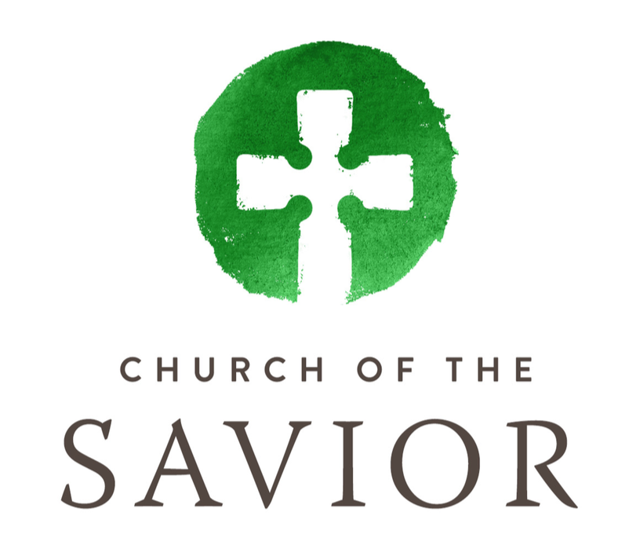
Ministry Description
Youth Pastor

Date: January 2024
Supervisor: Pastor of Family Ministries
Team: Staff
Status: Part-Time (10 hours per week)

Role: Help develop and implement vision (in partnership with Pastor of Family Ministries) for youth ministry at Church of the Savior

Primary Gifts Needed: leadership; teaching; shepherding; administration

Plan and Lead Youth Events
- Twice-monthly youth group gathering
- Monthly service project or fun event
- Confirmation preparation (every 1-2 years)

Develop Volunteer Leaders
- Recruit volunteer leaders
- Meet regularly with youth leaders; provide training and support

Build Relationships
- Attend Saturday evening worship services at Savior, greeting youth beforehand and connecting with them after the service
- Connect regularly with parents of youth

Administration
- Meet monthly with Pastor of Family Ministries
- Attend staff meetings and church events
- Ensure all in youth ministry follow Savior protection policies
- Work with Family Ministries Coordinator to ensure:
  - Regular announcements in newsletter and up front
  - Parents’ communications, no less than monthly
- Do other duties as assigned

Qualifications
- Mature Christian life
- College degree
- Prior experience working with young people
- Administration skills
- Ability to support Savior’s approach to ministry

Details
- Hours somewhat flexible
- $20.50 / hour. Paid vacation. Healthy staff culture.
- Please send resume to Pastor Mary Gonzalez: mary@friendsofthesavior.org

